Creating an NFL Schedule
Background:
The National Football League can trace its roots to 1920, the charter year of the American Professional Football Association (APFA), a league consisting of 14 teams scattered across five states. In 1922, the APFA changed its name to the National Football League (NFL), boasting a total of 18 teams [NFL 2013]. Scheduling was a rather simple, if not inelegant, affair. From 1920 to 1932, team schedules were left to the discretion of each team manager and were subject to change throughout the season. This arrangement produced very chaotic seasons with some teams playing as few as three games while other teams played as many as 12 games in a season. The result was a rather dubious bestowal of “League Champion”, a title fraught with scandal. In fact, it was the culmination of the 1932 season that forced the creation of a more formal NFL scheduling system (in that year, Green Bay chose not to play a “tentative” game against the Portsmouth Spartans as the season finale – a game which could have placed their league champion standing in jeopardy) [Uvena 2014].

In 1933 the NFL split into two divisions of five teams each (the NFL went through a substantial downsizing, reaching a low point of eight teams in 1932) [NFL 2013], introduced a playoff game between the two division champions, and created a three member committee to approve team schedules and declare which games where “official” and which games were “tentative”. The schedules, however, were still developed by each team manager and were not required to have a set number of games. In 1936, the NFL adopted the rule that all teams had to play the same number of games in a season (12 games), and provided a home and away formula (at least one home and away game with each team in the division and up to four inter-divisional games per season). By 1942 a standard formula for determining opponents emerged (eight games intra-division – one home and one away – and three inter-division games – home or away – but opponents were not specified). While the method for determining opponents was more formalized, the method for determining game dates was not. From 1937 to 1949, the schedule was hammered out over a period of days by the team owners where shear volume (voice) and stamina often determined which team got the better schedule [Uvena 2014].

As a direct result of the Washington Redskins owner’s untimely outburst during the 1950 scheduling session, the owners failed to produce a schedule. In frustration, the owners handed over the responsibility for making the schedule to the NFL Commissioner. For the next 21 years, using a sophisticated model (domino’s, paper matchsticks, and a huge piece of cardboard) the commissioner or a designated person would create the schedule manually in a few nights. The exception to this was the 1962 season when an IBM computer was used to generate a dozen schedules for use by the league [Uvena 2014].

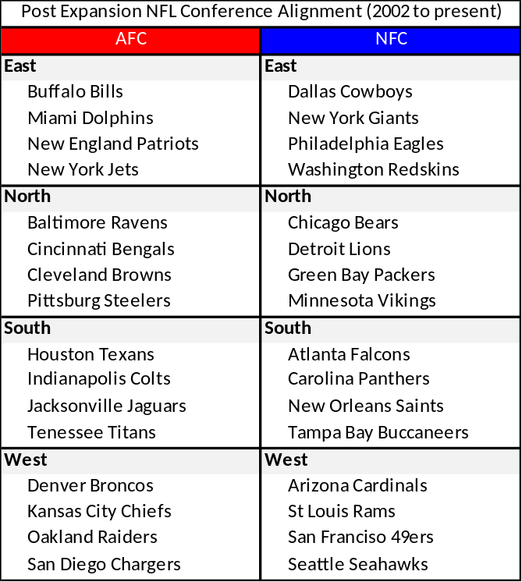
From 1970 through 2001, the NFL went through several expansion seasons and mergers resulting in a growth from 16 teams to 31 teams. The season itself grew from 14 games a season to 16 games a season (1978 was the first season with 16 regular season games). Each expansion and merger brought about a new formula for determining opponents. The only thing that remained constant was Val Pinchback, the NFL Vice President of Broadcasting. From January through May of each year (1971 to 1999), Val would work 10 to 12 hours a day, seven days a week creating about 12 schedules a year, ranking them and then recommending to the commissioner which schedule should be accepted [Uvena 2014]. This manual process coupled with at least three different formulas (and multiple modifications) for determining opponents resulted in numerous scheduling quirks. For example, through 2001, there were 25 instances of two teams that had not played each other in at least 20 years - the longest being 32 years between match ups for the Vikings and Colts. Another example was the 1973 season for the Jets when they opened the season with 6 consecutive away games due to the Mets 1973 pennant run [Uvena 2014].
Table 1: The NFL Conference and Division Alignment Following the 2002 Expansion

In 2002, the introduction of the Houston Texans brought the total number of NFL teams to 32. This allowed a restructuring (see Table 1) of the league into two conferences (AFC and NFC) consisting of four divisions each (four teams per division). The restructuring brought balance to the league, allowed “better” bye week rules, enabled a “more geographic centric” alignment of teams within divisions while preserving traditional rivalries, and enabled a cyclical and regular opponent formula. It did not, however, fix the manual scheduling process. From 2002 to 2004, the schedule was still created manually [Dilkina].

In 2005, the NFL moved to an automated process for creating schedules. Today, Howard Katz, Vice President of Broadcasting (aka the Schedule Czar), oversees the schedule development, leading four men and more than 100 computers over a period of 70 days. During the schedule development process they create and review over 500,000 schedules until the best one is identified and presented to the commissioner for approval [King]. A far cry from how schedules were developed in the 1920’s.

The Impact of Better Schedules
The cost of developing a schedule has gone from free (1920’s) to millions of dollars (2014). Is the amount of effort that goes into making a schedule warranted? You be the judge. The following is a recap of the fall 2013 primetime television Neilson ratings [Bibel].

Table 2: Nielson Facts from the 2013 NFL Regular Season (September 5 through December 30)
A few interesting facts from the NFL and the Neilson Company
- NFL has had a 31% increase in viewership since 2003; increasing average number of viewers per game from 15.5 million to 20.3 million in 2013
- For the second consecutive year, NFL games were the most watched TV shows for all 17 weeks of the regular season.
- NFL average viewership (20.3 million) nearly triples the average viewership of all other over-the-air networks (ABC, CBS, FOX, NBC) non-football primetime shows.
- FOX had its most viewed season ever with 21.1 million viewers per game.
- 2013 was CBS’ second most-watched season ever with an average of 18.6 million viewers.
- ESPN’s Monday Night Football was the most-watched series on cable for the eighth consecutive year with an average of 13.7 million viewers.
- CBS’ Thanksgiving Day Game (Oakland Raiders-Dallas Cowboys) was the most-watched show of the fall season with 31.7 million viewers.
- 34 of 35 most watched shows were NFL games; representing 81 percent of all television homes and 70 percent of potential viewers in the U.S.
- NFL games accounted for 46 of the 50 most-watched telecasts (aired between September 5th – and December 30th) among adults aged 18-49 – with CBS, FOX, ESPN and NBC each represented on that list.

A deliberate process for scheduling that places as many of the most interesting games as possible into primetime viewing periods has resulted in an explosive growth of popularity in the NFL as shown in Figure 1. [Schwartz][Greenberg]

And this popularity results in revenue. In 2011, the NFL renewed its contracts with CBS, FOX, NBC, and ESPN extending NFL’s television presence through 2022. The new contracts are worth an estimated $39.6B [NFL 2011] - almost a 100% increase from its previous 2006 contract worth $20.4B with the same networks. Clearly, the NFL’s newest scheduling process is succeeding.
Scheduling the NFL Today
Linear programming (currently Gurobi is the optimization software of choice [Gurobi]) is a critical component of the scheduling process. There are 256 games (32 teams each playing 16 regular season games over a 17 week period) to be scheduled. The games must be scheduled on Monday evenings (17 time slots over the season), Thursday evenings (16 timeslots over the season), Saturdays (annual decision – very few over the season), holidays (two games on Thanksgiving), Sunday evenings (17 time slots over the season), and Sunday afternoons (between 09 and 16 games each week all season long). The result is over 824 trillion combinations that must be implicitly evaluated [Batista]. In addition to the available timeslots for games, the NFL must also accommodate expectations, desires, and obligations to their contracts with NBC, FOX, CBS, and ESPN, and develop a loyal following with its own fledgling NFL Network on cable TV. Finally, there are multiple constraints (some permanent and others fleeting) that are unique to each venue, TV market, and team that must be satisfied in any given season. Over time, optimization has proven to be indispensible to development of the NFL schedule.
Figure 1: Popularity of the NFL in 2014

This document consolidates and categorizes most (if not all) of the long-term constraints associated with creating the NFL schedule for each season. The development of the schedule is broken into two stages. The first stage consists of determining opponents and home and away games. The second stage consists of fixing dates, times, and markets for the games identified in the first stage. The remainder of this paper is broken into two parts that align with the two stages of the NFL scheduling process. As with the previous sections of this paper, citations and links, if available, are provided.

First Stage – Applying the formula for opponents and locations of matches: The following year’s matchups are announced at the end of the regular season (traditionally the last days of December) through an NFL Communications release. The announcement includes the start date of the NFL Kick Off Weekend and the date and location of the Super Bowl [NFL 2014a]. The rules for determining opponents and whether the games are home or away are relatively simple. The formula is:
- Every team will play 16 games
- Every team will play each team in its division twice (once at home and once away)
- Each team in a division will play all teams from another division within its conference on a three year rotating cycle (intra-conference games)
  - Two games at home, two games away
  - The home and away games are based on who traveled the last time the two conferences played each other
  - The extended intra-conference rotation plan for the six years starting in 2014 follows:
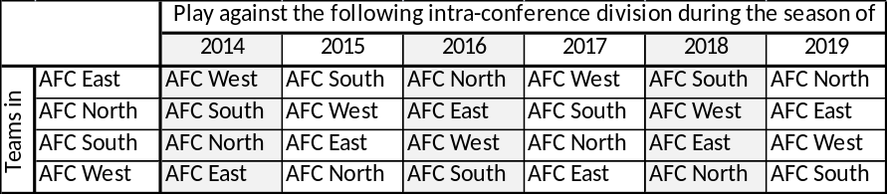

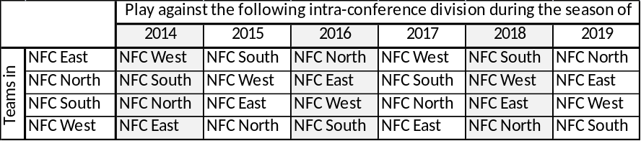

- Each team in a division will play all teams from a division in the other conference on a four year rotating cycle (inter-conference games)
  - Two games at home, two games away
  - The home and away games are based on who traveled the last time the two conferences played each other
  - The extended inter-conference rotation plan for the eight years starting in 2014 follows:
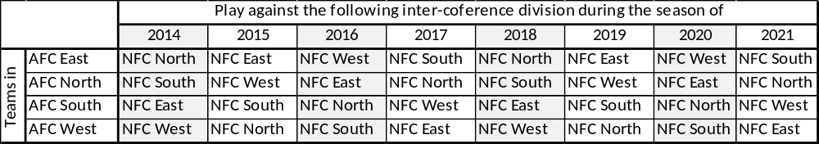

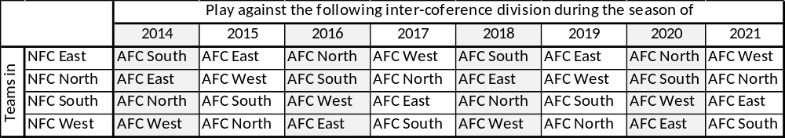

- Each team will play two other teams in its conference based on the prior year’s standings (performance matches)
  - The teams are selected from the two divisions within the conference that are not on cycle
  - The games will match teams of the same performance (1st against 1st, 2nd against 2nd, 3rd against 3rd, 4th against 4th)
  - One game will be at home, one will be away
- Each non-west coast team scheduled to play a division with West coast teams can only play one away game per conference. (Anti-Jetlag Movement)
  - Prevents some teams within a division from playing two away games on the West Coast (@San Francisco and @Seattle) while other teams within the division have none (@St. Louis and @Arizona).
  - Already accounted for in established home and away cycle

Second Stage – Schedule of dates for all matches: The upcoming year’s schedule of games (dates and times) are released in the spring (generally in April). The announcement includes highlights of the season and the listing of caveats (when flex schedule begins and other “factoids”) [NFL 2014b]. The rules for creating the schedule are numerous, if not onerous, and over constrain the problem. As a result, each year you will see some number of violations of a few rules. The rules consist of three types of constraints: Hard constraints—those that cannot be violated (but sometimes are); Soft constraints—those that we prefer to not violate but if they are, the resulting schedule should not be invalidated; and Television constraints—those that ensure the contracts with each network are honored. Sometimes the schedules are over constrained and the league finds creative ways to remedy the problem (the international series and Thursday Night Football Games on Saturdays)

"This is the annual ritual of finding out how stupid I am. We work for months and months in this room and ‘What were they thinking?’ It comes with the territory.”
- Howard Katz, Vice President of Broadcasting, NFL
- “Schedule Czar”

Scheduling Rules (those constraints which cannot be violated):
- Each game will be played exactly once during the season
- Each team must play once a week for each of the 17 weeks of the season (consider the BYE as a game)
- BYE games can only happen during weeks 4 through the week before Thanksgiving. In 2015, Thanksgiving is week 12, therefore BYE games can only be played from week 4 through week 11)
- No team that had an early BYE week (week 4) the previous season will have an early BYE (week 4) in the present season
- Teams having an international game will have their BYE game the following week
- Teams playing an international game will be at home the week before the international game (unless they request otherwise – for this course assume no team makes that request)
- Two teams cannot play back to back games or play against each other the week before and the week after a BYE
- No team plays 4 away/home games consecutively during the season
- No team plays 3 consecutive home/away games during weeks 1,2,3,4,5 and 15,16,17
- New York Teams don’t want to play late home games on Yom Kippur and Rosh Hashanah
- Week 17 games will consist only of divisional games
- No team plays more than two road games against teams coming off their BYE

- There are two Monday night games on week 1
- There is only one Monday night game during weeks 2 through 16
- The home team for the late Monday night game on week 1 will be a team one of the following five teams (ARI, SD, SF, OAK, SEA)
- There is only one Thursday night game during weeks 1 through 16
- There is only one Sunday night game scheduled during weeks 1 through 16
- There will be two Saturday Night games, one each night in weeks 15 and 16
(The Saturday rule depends on how many Saturdays there are in December and in which month week 17 falls. Basically, if Thanksgiving is week 12, then there are Saturday Night games during weeks 15 and 16. If Thanksgiving occurs in week 13, there are two Saturday games - one early and one late - that happen during week 16).
- Superbowl champion opens the season at home on Thursday night of week 1
- All teams playing road Thursday Night games are home the previous week
- There are two Thanksgiving Day games: DET hosts the early game and DAL hosts the late game. (The networks alternate each year who gets the early game and who gets the late game)
- FOX and CBS each will get 8 doubleheaders from week 1 through 16; both networks have a double header on Week 17
- FOX and CBS cannot have more than two double headers in a row during weeks 1 through 16.
- Every team must play exactly one short week game during the season. A short week is defined as a Sunday game in week “w” and a Thursday game in week “w+1”. As a result, two of the six teams playing on Thanksgiving Day must play against each other the following Thursday night.
- No team playing on Monday night in week “w” can play Thursday during week “w+1” or Thursday “w+2”
- NYG and NYJ cannot play at home on the same day
- NYG and NYJ cannot play on the same network on Sunday afternoon
- OAK and SF cannot play on the same network on Sunday afternoon
- West Coast and Mountain Teams (SD, SF, OAK, SEA, ARI, DEN) cannot play at home during the Sunday early afternoon game (1:00 PM EST)
- CBS and FOX will have at least three 1PM Sunday afternoon games each week.
- Teams can play no more than 5 prime time games in a season (with no more than 4 of them being broadcast on NBC). Thanksgiving Day games do not count as prime time games. Only Thursday night, Saturday Night, Sunday Night, and Monday Night count as prime time games.

Firm Constraints (those constraints the NFL will violate only to get the best schedule):
- All teams playing Thursday games cannot play Monday night the previous two weeks.
- Teams cannot play at home on Stadium blackout dates.
- CBS and FOX afternoon games will be diverse. This is a hard one to describe, but with the exception of week 17, they shouldn’t have all games from a single division. There should be a good distribution of games with respect to quality (on a 1, 2, 3 scale). There should be games from different time zones in a given week for each network (FOX, CBS)
- All teams must play at least 2 away/home games every 6 weeks (exclude BYE games from this constraint)
- All teams must play at least 4 away/home games every 10 weeks
- No team will play three consecutive away games between weeks 4 through 16 (if they do, they can only play one such set).
- No team plays consecutive road games involving cross-country trips (coast to coast) unless team requests it (for the purpose of this course, assume no one requested consecutive cross-country trips)
- Two of the four teams that played Thanksgiving day games must play Thursday the following week
- No team playing a Thursday night game should travel more than one time zone from home
- NYG and NYJ cannot play during the same time slot on Sunday. This may be violated only if both teams are on the road. The idea here is you do not want fans with tickets for one team sitting at home watching the game instead of being in the stadium.
- OAK and SF cannot play during the same time slot on Sunday. This may be violated only if both teams are on the road. The idea here is you do not want fans with tickets for one team sitting at home watching the game instead of being in the stadium.
- CBS and FOX may have fewer than 5 games each on a Sunday exactly once per network.

Soft Constraints (those constraints the NFL will try to honor if they don’t break a good schedule):
- No team will open the season with two away games
- Florida teams should not play early home games in the month of September (this is generally a “by request” constraint). Assume all Florida teams requested “no early games”.
Multiple Objectives (those conditions the NFL wishes to ensure are as good as possible):
- Maximize separation between each team’s Thursday game and their BYE game
- Minimize number of teams playing road game after road MNF game.
- Maximize the number of late-season division games. Allow weeks 11 through 17 to be considered “late-season”.
- Minimize the number of times Pacific Time zone teams play at 1:00 PM in the Eastern Time Zone (attempt to share the burden equally between teams within a conference)
- Minimize the number of division series that end in the first half of the season.
- Minimize the number of division series that are played less than three weeks apart
(Constraints 5 and 6 can be implemented by trying to keep to keep at least 8 weeks between games in a division series and recognizing that having 3 weeks between games is worse than having 6 weeks between games – i.e., the further apart you can keep a division series, the better off the schedule will be)
- Minimize the number of weeks in which CBS and FOX “lose” their key games or an entire division. (This means try not to allow one entire division to be broadcast on prime time or stick FOX and CBS with a week or really bad games – Good games and bad games are subjectively assessed and scored on a scale of 1, 2, and 3).
- Minimize the disparity in network game quality across the season. Admittedly, game quality is a subjective assessment. This is based on the 1, 2, 3 scoring system.

Bibliography

[Batista] | Batista, J., The Art and Science of Scheduling Meet in the NFL Office, The New York Times, 19 April, 2012; http://www.nytimes.com/2012/04/20/sports/nfl-schedule-makers-try-their-best-to-please-everybody.html?pagewanted=all
[Bibel] | Bibel, S., NFL 2013 Recap: 205 Million Fans Tuned in; 34 of 35 Most Watched TV Shows This Fall, Zap2It, 8 January, 2014; http://tvbythenumbers.zap2it.com/2014/01/08/nfl-2013-tv-recap-205-million-fans-tuned-in-34-of-35-most-watched-shows-this-fall/227726/
[Brandon] | Brandon, J., Why Detroit Lions and Dallas Cowboys Always Play on Thanksgiving Day, examiner.com, 23 November, 2011, http://www.examiner.com/article/why-the-detroit-lions-dallas-cowboys-always-play-on-thanksgiving-day
[Brinson] | Brinson, W., NFL Owners To Consider ‘Time Zone Travel’ Rule, CBS Sports, 11 December, 2011; http://www.cbssports.com/mcc/blogs/entry/22475988/33803287
[Dilkina] | Dilkina, B, and Havens, W., The U.S. National Football League Scheduling Problem, IAAI Emerging Applications
[ESPN] | NFL’s Final Week Only Division Games, ESPN.com news, 20 April, 2010
[Greenberg] | Greenberg, C., These Maps Will Tell You Which Athlete And Sport Your State Is Most Obsessed with, Huffington Post Sports, 22 April, 2014
[Gurobi] | Gurobi Optimization, The National Football League Chooses Gurobi; The NFL drafts Gurobi to help optimize the next season’s schedule, Gurobi Press Releases, 4 March, 2014; http://www.gurobi.com/company/news/the-national-football-league-chooses-gurobi
[King] | King, P., How the 2014 Schedule Was Made, The Monday Morning Quarterback, 24 April, 2014; http://mmqb.si.com/2014/04/24/making-of-2014-nfl-schedule/
[NFL 2011] | NFL Renews Television Deals, ESPN, Associated Press, 14 December, 2011, http://espn.go.com/nfl/story/_/id/7353238/nfl-re-ups-tv-pacts-expand-thursday-schedule
[NFL 2013] | National Football League, The Chronology of Professional Football, 2013 NFL Record and Fact Book; http://static.nfl.com/static/content/public/image/history/pdfs/History/2013/353-372-Chronology.pdf
[NFL 2014a] | National Football League, 2014 Opponents Determined, NFL Communications, 30 December, 2013, http://nfllabor.files.wordpress.com/2013/12/12-30-13-2014-opponents-determined.pdf
[NFL 2014b] | National Football League, 2014 NFL Schedule Announced, NFL Communications, 23 April, 2014, http://nfllabor.files.wordpress.com/2014/04/2014-schedule-release1.pdf
[Schwartz] | Schwartz, N. and McGary, T.,, The NFL Is The Most Popular Sport in America for the 30th Year Running, USA Today, 26 January, 2014; http://ftw.usatoday.com/2014/01/nfl-most-popular-sport-poll
[Smith] | Smith, D., Producing the NFL Schedule a long, hard task, NBC Sports, April 19, 2012; http://profootballtalk.nbcsports.com/2012/04/19/producing-the-nfl-schedule-a-long-hard-task/
[Uvena 2014] | Uvena, I., Pro Football Schedules: A complete Historical Guide from 1933 to the Present, McFarland, 2014

In the 2014 season, the San Francisco 49ers moved into their new stadium in Santa Clara and were not able to host Monday or Thursday night football games (except for Thanksgiving) because no one could predict the impact of an NFL game on the evening traffic patterns during the work week. Similarly, the Minnesota Vikings were not allowed to host Monday night or Thursday night games because they were playing in the University of Minnesota’s football stadium while the new Viking’s stadium was being built. Additionally, the Vikings could not play at home on the same weekend the Gophers played at home.

